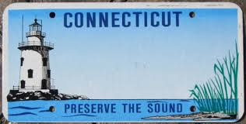

**ROAD TO NASHVILLE**