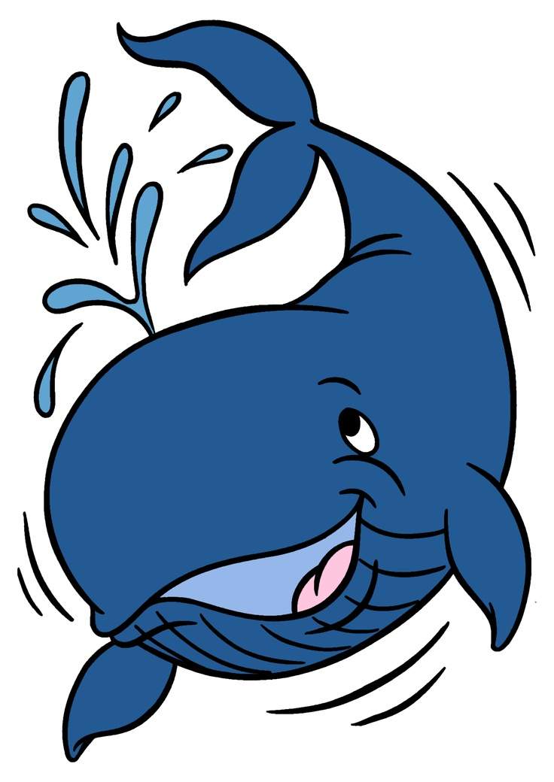

***2016***

**Making a Splash in Nashville**

**Connecticut DECA**

**BE EPIC**

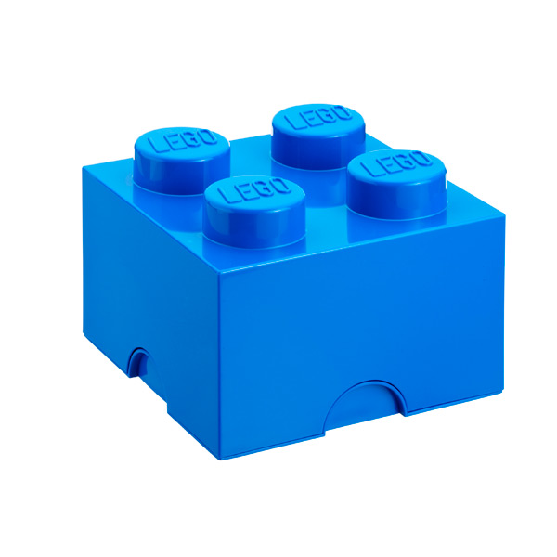

**The Building Blocks to Nashville 2016**

Connectiut DECA

BE EPIC



**Nashville 2016**

**CT DECA**

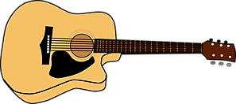

**Connecticut DECA**

***BE EPIC***

Nashville 2016

**NASHVILLE**

**2016**

***CONNECTICUT IS OUR TEAM***

**Nashville 2016**



**CONNECTICUT DECA**

**BE EPIC**



**Flying high over Nashville**

**CONNECTICUT DECA 2016**



**Connecticut DECA**

**Bringing bright ideas to Nashville**

**BE EPIC 2016**



**BE EPIC**

**2016**

**Connecticut’s Road Map to Nashville**



**Connecticut DECA**

**Square dancing to Nashville and back**



We the People

Of the United States in Order to form a more perfect Union, establish Justice, insure domestic Tranquility, provide for the common defense, promote the general welfare, and secure the blessings of liberty to ourselves and our posterity, do ordain and establish this Constitution for the United States of America

Connecticut DECA

Heads to the Volunteer State

Nashville 2016



**Praying we go to Nashville!**

**Connecticut DECA**

**2016**



**BE EPIC in the Music City**

Nashville

**DECA 2016**

Connecticut